LAS VAQUERAS SPRING RIDE
APRIL 19-21 2024
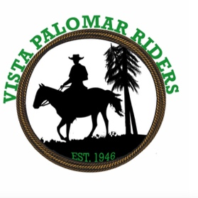
Location is Vista Palomar Riders, Bonsall, California
Trail Riding • Obstacle Course • Sorting!
Event Dates: April 19-21 Friday through Sunday
This event includes LV Members and Applicants

Join the fun for your catered weekend of horsing around. There will be daily trail rides, trail obstacles challenge and sorting challenge. There will be beautiful buckles for each competition.

2 arenas, obstacle area, cow pens for sorting and lunging.
Can't attend? Hope you can join us for Saturday Dinner!

Meals included for Friday/Saturday/Sunday in event fee
April 19 Friday: lunch, dinner
April 20 Saturday: Breakfast, lunch, dinner provided
April 21 Sunday: Breakfast provided

Event Fees:
- Members $425 Friday, Saturday, Sunday
- Applicants $475. Friday, Saturday, Sunday
- Saturday Dinner Only $ 25. Saturday April 20th
- Horse pens provided
- Deadline to sign up is April 5th
PAYMENTS:
Credit Card via the LV website www.lasvaquerasridingclub.com
PayPal direct to LasvaquerasSJC@gmail.com or via the website
Check by mail: Payable to Las Vaqueras P.O. Box 1493, San Juan Capistrano, CA 92693
No arrivals before 2 pm Thursday • Waiver required to sign at check in
No Refunds • No dogs • No smoking
• LV and VPR waivers required
•Dry Camping Only No RV hookups
• Showers and bathrooms provided
• Bring your own horse feed
• Optional. Let us know your stall preference/neighbor and we will do our best to accommodate. Stalls will be assigned
• Vista Palomar Riders Location:
973 Little Gopher Canyon Rd, Bonsall, CA 92003
For directions go to www.vistapalomarriders.com
Visit this site for video, photos and corral map

Questions? Contact Susan Miranda c/o 949-689-9687 or smirandacpa@mac.com

